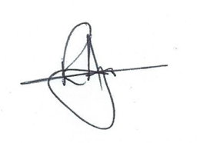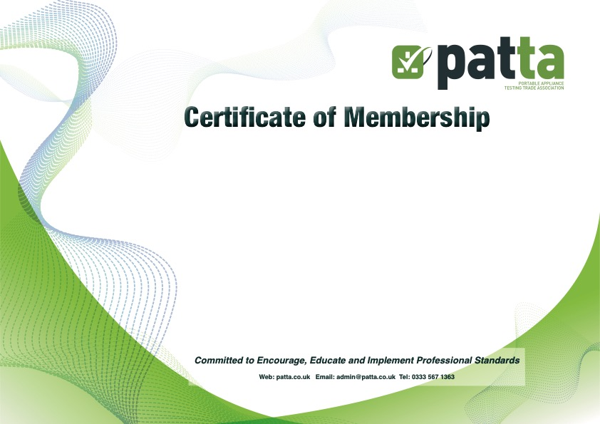

Ragstones Ltd

**Scope of Certification:** Portable Appliance Testing business

**Certificate number:** 180909

**Certification Date:** 1st March 2019

This certificate is valid for 3 years from the date above unless membership is terminated sooner.

Signed on behalf of the Directors ___________________

This is to certify that:

**Is a registered member of the Portable Appliance Testing Trade Association and has agreed to abide by the association’s codes of practice and minimum standards of appliance inspection and testing.**